Customer Test Program

Customer | : | Termomeccanica Pompe, Italy
Ultimate User | : | ADNOC
Customer Reference | : | 11-20-P-2142-02 / 11-20-P-2143-02 / 11-20-P-2144-02
Pump Manufacturer | : | Termomeccanica Pompe, Italy
Flowserve Test Project | : | 2023RSD08TL
Seal type and size | : | UHTW/UHTW-4.750/4.750
Flowserve order no. | : | 950969

Project | Prepared by | Approved by | Description | Date
2026RSD03TL | M. Tagzait |  |  | 04-June-2026

CONTENTS PAGE
1.0 Introduction 3
2.0 Objective 3
3.0 Field Conditions 3
4.0 Test Conditions 4
5.0 Test Seal Configuration 4
6.0 Test Set-up 5
7.0 Test Procedure 6
7.1 PRE-TEST WORK 6
7.2 DYNAMIC TEST 7
7.3 TEST PLANNING 7
Test 1 7
Test 2 7
7.4 MONITORING OF DYNAMIC TEST 8
7.5 POST TEST WORK 8
7.6 REPORTING 8
Appendix I Mechanical Seal Assembly Drawing 9
Appendix II Tester Assembly Drawing 10
Appendix III System Drawing 11
Appendix IV P&ID Test Unit System 12

Introduction
Early 2021, the UHTW/UHTW 4.750” was designed for the multistage BB5 MESB pump from Termomeccanica.
The mechanical seals are for three, double suction, surface water injection pumps. The seal chamber pressure varies from normal 9 to maximum 95 barG. The static design pressure shall be 350 barG and dynamic design pressure 150 barG. The sealing system consists of a plan 53B with automatic top-up unit. The normal barrier pressure is currently set at 70barg.
The seals experienced several failures, refers to RCA on the subject. The latest agreed action is to use Graphite loaded silicon carbide seal faces instead of the currently used reaction bounded silicon carbide. This test program was initiated to check the seal performance with the new seal face material.

Objective
The objective is to verify the seal performance of the UHTW/UHTW mechanical seal as per drawing F000904152 (Appendix I).
The acceptance criteria for test are:
- The expected normal barrier fluid consumptions rates are 100 g/h per seal cartridge.
  - The expected normal barrier fluid consumption rate for the outer seal is 50 g/h
  - The expected normal barrier fluid consumption rate for the inner seal may vary with process pressure 5-50 g/h.
- No evidence of chipping or deterioration of the contact surfaces of the in- and outboard faces. Due to the use of hard faces, some contact traces can be expected.

Field Conditions
Seal type and size : UHTW/UHTW 4.750/4.750
Seal Configuration : Dual pressurized face to face
Material code : YX9X/DXYX
Pump fluid : Aquifer water
Seal chamber pressure : 12 barG Norm, 9-98 barG
Product Temperature : 75°C Norm, 4-85°C
Barrier fluid : Potable Water and MEG/Water 30/70
Barrier pressure : 70 barG
Barrier temperature : Approx. 60°C (outlet cooler, inlet seal)
Speed : 2980 rpm
API-plan : 53B with automatic refill unit
Flowserve order number : 950969
Assembly drawing : D0527190 (Appendix I)
System drawing : D0525801 (Appendix III)

Test Conditions
Plug Seal type and size: : UHTW 4.750
Job Seal type and size : UHTW/UHTW 4.750/4.750
Seal Configuration : Dual pressurized face to face
Material code : YX9X/DXYX
Pump fluid : Potable water
Seal chamber pressure : 12 barG Norm
Product Temperature : 65°C
Barrier fluid : Potable water
Barrier pressure : 70 barG
Barrier temperature : Approx. 55- 60°C (outlet cooler, inlet seal)
Speed : 2980 rpm
API-plan : 53B on the job seal
: 53B on plug seal
Barrier flow rate : To be defined.
Test assembly drawing : F000904152 (Appendix II) Upgraded.

Test Seal Configuration

Inboard Seal : UHTW-4.750
Stationary face : C0618722SL (75%)
Material : Reaction Bonded Silicon Carbide
Rotating Face : C0619339SL
Material : Reaction Bonded Silicon Carbide

Outboard Seal : UHTW-4.750
Stationary face : C0618722SL (75%)
Material : Reaction Bonded Silicon Carbide
Rotating Face : C0618723SL
Material : Reaction Bonded Silicon Carbide

Test Set-up
The test will be executed on test rig B. This unit is equipped with a 65 kW, frequency driven motor. Seal will be built as per drawing F000904152 rev- (Appendix II). For testing, the seal with counterclockwise rotation (Free End seal) will be used.
The test housing and adapter sleeve will be assembled within maximum allowable angular and radial misalignment according to API-682 (fourth edition) section 6.1.2.8(b) and 6.1.2.13.
The barrier cavity in the job seal will be connected to the plan 53 reservoir and be filled and pressurized using the support system. The cooling coil in the plan 53 will be used to keep the temperature of the barrier around 55 - 60℃ out of the cooler, towards the seal.
Measuring the IB leakage is key in determining the success of the test. Since the IB leakage will be mixed with the barrier, it cannot be measured directly. By visually measuring the layer of water in the API Plan 53 reservoir, the amount of accumulated leakage can be calculated.
See Appendix IV for the P&ID of the test unit system.

Test Procedure

PRE-TEST WORK
- At first installation the alignment of the seal chamber will be measured and recorded.
- Prior to first installation all mechanical seal and test components will be inspected for proper construction, compliance to drawing and material.
- Check seal faces for flatness. If not flat within two light bands, re-lap the faces.
- A surface profile of the "running area" of both, the rotating and stationary faces will be recorded as well as the face roughness (Ra value).
- The mechanical seal cartridge will be assembled according installation instructions indicated on drawing F000904152 rev. A (Appendix I).
- Seal cartridge will be installed on the test unit according drawing F000904152 rev.- (Appendix II) and connected to the Plan 53B system.
- The barrier side will be statically pressurized to the dynamic test pressure for a period of 10 minutes to check the tightness of the mechanical seal assembly;
- The product side will be statically pressurized to the dynamic test pressure for a period of 10 minutes to check the tightness of the mechanical seal assembly;
- The breakout torque will be measured immediately after pressurizing and after 10 minutes of static pressurization.

DYNAMIC TEST
In all tests only the seal cartridge will be tested, no product side will be simulated.
The following tests are scheduled.
      - Dynamic test with the FE seal at the following conditions:
Test duration : 100 hours, depending on stability of performance
Product fluid : Water (potable)
Barrier temperature : depends on how much heat will be generated.
Barrier pressure : 70 barG
Speed : 2980 rpm
Barrier pressure, face temperature and leakage of both inboard and outboard seal will be recorded.
      - Dynamically test with FE seal with a plug seal at the following conditions:
Test duration : 100 hours, depending on stability of performance
Product fluid : 70% water + 30% monoEthylene glycol
Barrier temperature : depends on how much heat will be generated.
Barrier pressure : 70 barG
Speed : 2980 rpm
Barrier pressure, face temperature and leakage of both inboard and outboard seal will be recorded.

TEST PLANNING

Test 1
To be started on August 23, 2023

Test 2
To be started on August 29, 2023

MONITORING OF DYNAMIC TEST
Seal Performance, by means of a data acquisition system the following parameters will be recorded with an interval of 5 minutes:
- Barrier inlet temperature;
- Barrier outlet temperature;
- Barrier pressure;
- Speed;
- Torque.
By hand at regular intervals during day shift:
- Barrier inlet temperature;
- Barrier outlet temperature;
- Barrier pressure;
- Speed;
- Barrier flow rate;
- Leakage of in- and outboard seal;
- Torque.

POST TEST WORK
- Directly after the test is stopped the break-out torque will be measured under pressurized condition; This will be repeated 10 minutes after the first measurement;
- Drain seal and disassemble mechanical seal from test rig;
- The mechanical seal will be dismantled for inspection;
- Following parts of the job and plug seal will be inspected and observations recorded:
- Seal faces;
- Anti-rotating pins:
- Landing areas
- Balance diameters
- A surface profile of the "running area" of both the rotating and stationary faces of the job and plug seal will be recorded. The face roughness (Ra value) will be recorded in radial direction.
- Photographs of both rotating and stationary faces of the job and plug seal will be made.

REPORTING
- Every deviation from the test program will be recorded with a Test Program Change Notice (TCN);
- A detailed test report will be provided after completion of the complete test program.

- Mechanical Seal Assembly Drawing
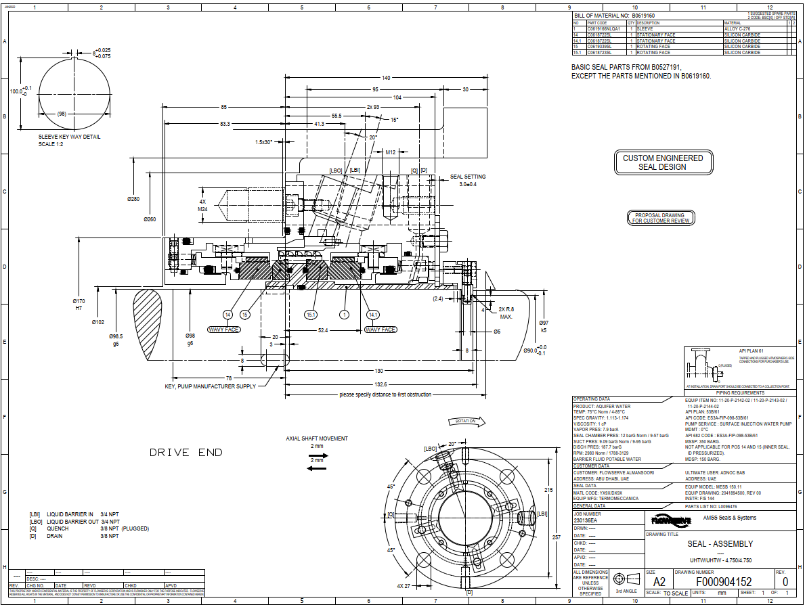
- Tester Assembly Drawing
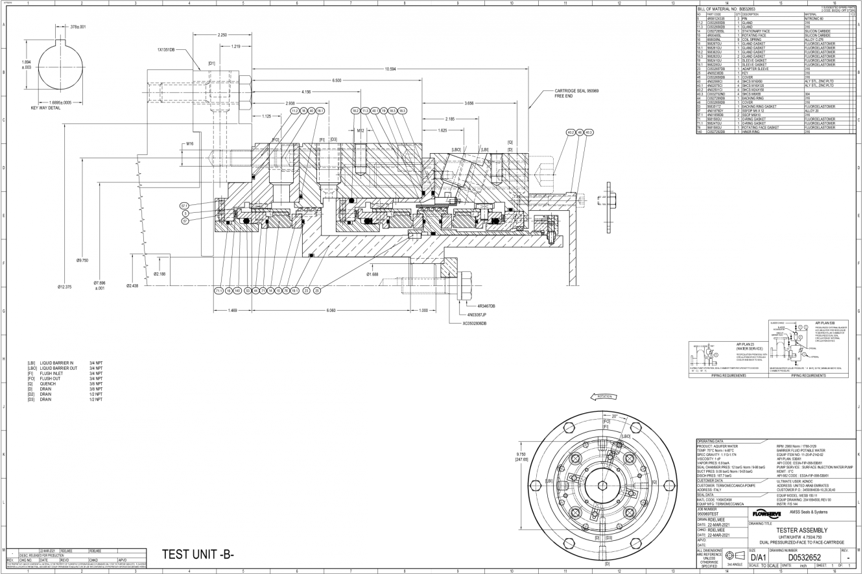
- System Drawing
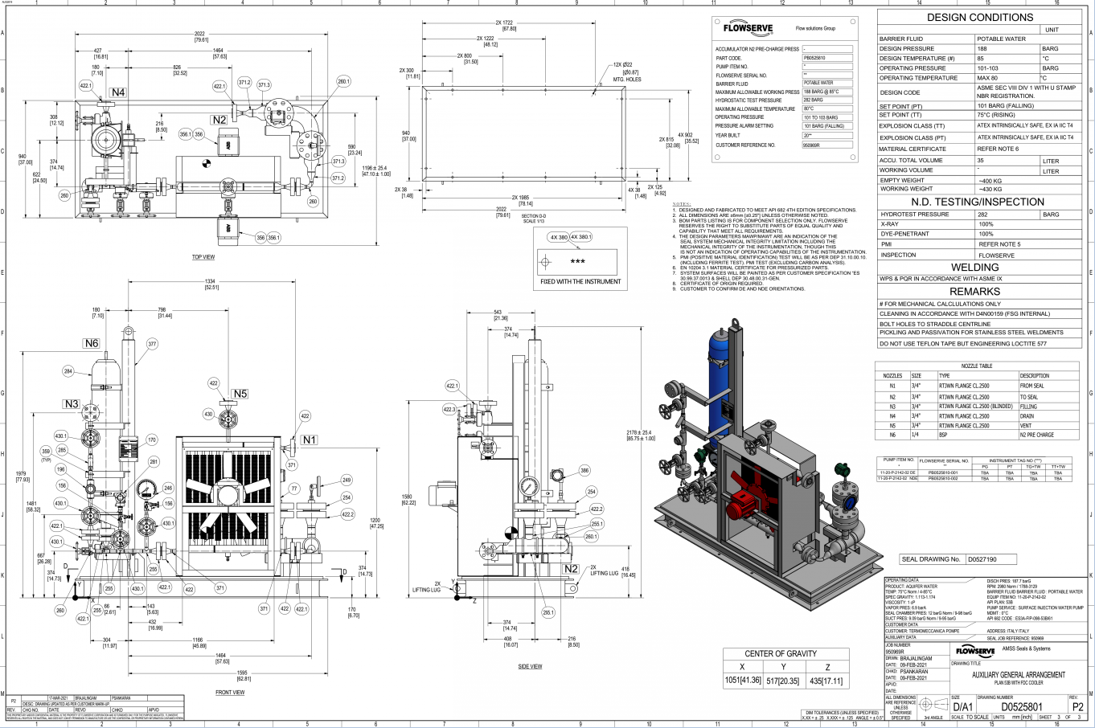
- P&ID Test Unit System
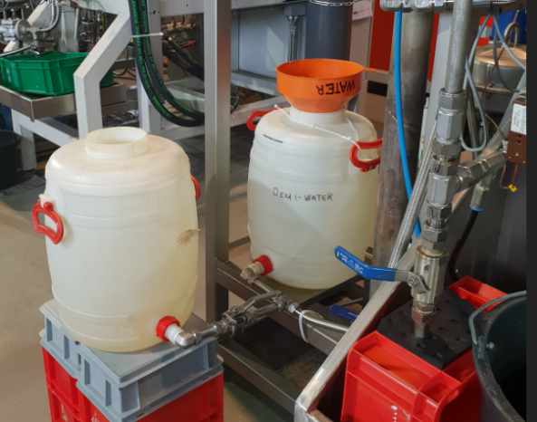
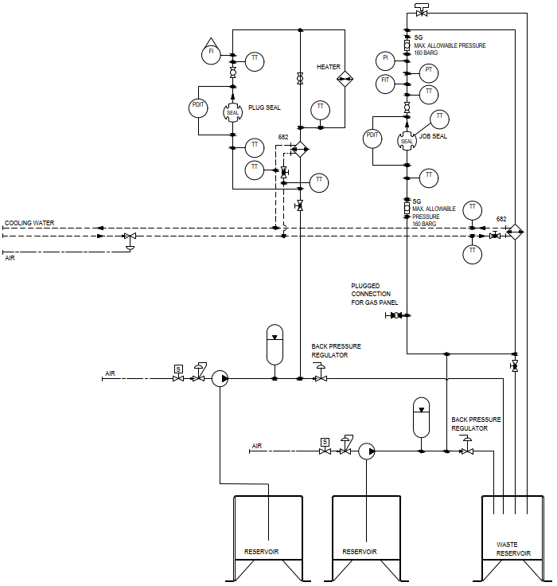
Job seal shall contain 2 drums for the barrier fluid to cope with the high barrier consumption.

